CASE STUDY ON THE ROLE OF INDIVIDUALS IN CONSERVING NATURAL RESOURCES AND
ENGINEERING MATERIALS

Submitted by: Yuvraj Vinayak Suryawanshi
Class/Roll No.: 181
Subject: Environmental Studies
Academic Year: 2026-2027

Index
Sr. No. | Topic | Page No.
1 | Introduction | 1
2 | Objectives of the Study | 1
3 | Natural Resources | 2
4 | Importance of Natural Resources | 2
5 | Engineering Materials | 3
6 | Need for Conservation | 3
7 | Role of Individuals in Conservation | 4
8 | Conservation of Engineering Materials | 5
9 | Reduce, Reuse, Repair and Recycle | 6
10 | Sustainable Consumption and Waste Management | 6
11 | Role of Engineering Students and Society | 7
12 | Benefits and Challenges | 7
13 | Conclusion | 8
14 | References | 8

1.Introduction
Natural resources and engineering materials play a vital role in human life, industrial growth and technological progress. But rapid urbanisation, industrial development and excessive consumption are causing their depletion and increasing environmental problems. Hence, proper utilisation, minimum wastage, reuse and recycling of resources are important for sustainable development. Every individual can help by using water, energy and materials wisely, reducing waste and following proper waste disposal methods, while industries and government authorities must also take effective measures for resource conservation.

2.Objectives of the Study
The main objectives of this report are:
• To understand the significance of natural resources and engineering materials.
• To study the importance of conserving these resources.
• To analyse the role of individuals in preventing resource wastage.
• To learn about the importance of reuse, repair and recycling.
• To encourage sustainable and responsible practices in everyday life.

3.Natural Resources

Natural resources are substances and materials available in nature that are essential for human survival and progress. They include water, forests, land, minerals, sunlight, wind and fossil fuels. These resources are broadly divided into renewable and non-renewable resources. Renewable resources can be naturally restored, whereas non-renewable resources such as coal, petroleum and minerals exist in limited quantities. However, renewable resources may also become scarce when they are consumed faster than their natural rate of regeneration.

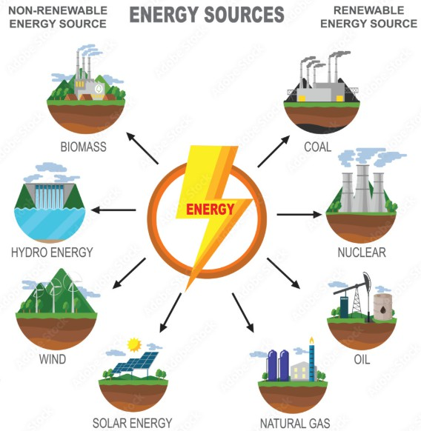
Fig. 1: ClassificationofNatural Resources
4.Importance of Natural Resources
Natural resources play an important role in human life, agriculture, industries and economic progress. Water is required for drinking, irrigation and industrial activities, while forests, soil and minerals supply food, raw materials and suitable habitats.
Key importance:
• Support human requirements and economic growth.
• Supply raw materials and energy for industrial activities.
Since natural resources are finite, their careful utilization and conservation are essential to maintain environmental balance and ensure their availability for future generations.

5.Engineering Materials

Engineering materials are essential for developing and manufacturing products, machines, buildings and infrastructure. Common examples include metals, plastics, concrete, glass, ceramics, wood and composite materials. Their selection depends on properties such as strength, durability, weight, flexibility and cost.
Manufacturing these materials requires natural resources and energy. Therefore, their proper utilization, reuse and recycling are necessary for conserving resources, minimizing waste and reducing environmental impact.



Fig. 2: Common Engineering Materials and Their Applications

6.Need for Conservation
Conservation of natural resources and engineering materials is essential because excessive use can lead to resource depletion, pollution and environmental degradation.
Overuse of minerals, groundwater and forests can disturb ecosystems, while improper disposal of metals, plastics and construction materials increases waste and pollution.
Conservation helps reduce resource consumption, save energy and control waste through efficient utilization, reuse and recycling. It also ensures that important resources remain available for future generations.

7.Role of Individuals in Conservation
Individuals use natural resources every day through water, electricity, transportation and various household activities. Responsible practices can help minimize wastage and protect these valuable resources.
Important practices include:
• Save water and fix leaking taps and pipes.
• Turn off electrical devices when they are not in use.
• Prefer public transport, carpooling, walking or cycling.
• Minimize unnecessary use of paper and other materials.
These simple measures can reduce resource consumption, prevent wastage and contribute to environmental conservation.

8.Conservation of Engineering Materials
Engineering materials require natural resources and energy during manufacturing, so their efficient utilization is essential. Increasing product life through regular maintenance and timely repair can reduce material consumption and minimize waste.
Important practices include:
• Repair damaged products instead of replacing them unnecessarily.
• Reuse furniture, tools and household materials whenever possible.
• Recycle metals such as steel, aluminium and copper.
• Avoid unnecessary use of single-use plastics.
Choose durable, reusable and resource-efficient products.

9.Reduce, Reuse, Repair and Recycle

The 4R principle – Reduce, Reuse, Repair and Recycle provides an effective method for conserving natural resources and reducing waste.
Reduce means minimizing unnecessary consumption and buying only essential products. Reuse means using products repeatedly instead of discarding them after a single use. Repair means restoring damaged products to extend their useful life and avoid replacement.
Recycle means collecting and processing waste materials so that they can be transformed into new useful materials or products.
Following these principles helps reduce waste, conserve raw materials, save energy and support environmental sustainability. It also reduces pollution and decreases the pressure on natural resources. Adopting the 4R principle in daily life can create responsible consumption habits and contribute to a cleaner and healthier environment.

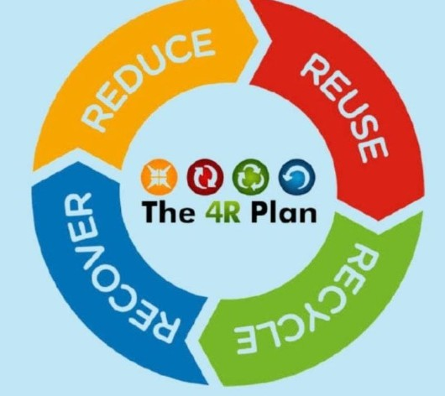
Fig. 3: Reduce→ Reuse→Repair→Recycle
10.Sustainable Consumption and Waste Management
Sustainable consumption means using goods and natural resources carefully while considering their impact on the environment. Individuals can encourage sustainable consumption by selecting long-lasting products, avoiding unnecessary purchases and minimizing the use of excessive packaging.
Effective waste management is also essential for conserving useful materials. Waste should be properly segregated so that recyclable materials such as paper, metals, glass and suitable plastics can be collected and processed.
Organic waste can be converted into compost, while electronic waste should be handed over to authorized collection and recycling systems. Proper waste segregation helps recover valuable materials and prevents them from being wasted in landfills.

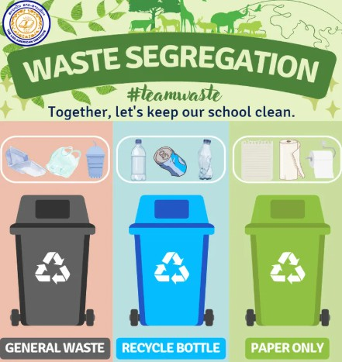
Fig. 4: Waste Segregation and Recycling
11.Role of Engineering Students and Society
Engineering students have an important role in resource conservation because their technical knowledge can be applied to create sustainable solutions. Students can undertake projects related to renewable energy, water management, recycling, waste reduction and energy-efficient technologies.
Engineers can also design products that require fewer materials while maintaining the necessary strength and performance. Selecting suitable materials can help reduce environmental impact, production costs and resource consumption.
Educational institutions, industries and local communities also play an important role. Colleges can encourage waste segregation and energy saving, while industries can improve production efficiency and reuse or recycle manufacturing waste.
Resource conservation becomes more successful when individuals, engineers, industries and government authorities work together.

12.Benefits and Challenges
Resource conservation offers environmental, economic and social benefits. It helps reduce pollution, waste generation, deforestation and stress on natural ecosystems. Proper and efficient utilization of resources can also lower material and energy expenses.
However, conservation faces challenges such as limited awareness, easy availability of disposable products, excessive consumption patterns and insufficient recycling facilities. These challenges can be reduced through education, public awareness, improved infrastructure and responsible consumer behaviour.

13.Conclusion
Natural resources and engineering materials are essential for modern society and technological progress. However, excessive consumption, careless utilization and improper disposal can result in resource depletion, pollution and environmental degradation.
Individuals can contribute significantly by saving water and electricity, reducing fuel usage, avoiding unnecessary consumption, repairing damaged products, reusing materials and properly recycling waste.
Engineering students can also contribute by developing innovative, sustainable and resource-efficient technologies. Conservation is therefore not only the responsibility of governments and industries. Every individual has an important role in using resources responsibly and building a sustainable future.
14.REFERENCES
- Environmental Studies – Natural Resources and Environmental Conservation, textbook and classroom notes.
- Ministry of Environment, Forest and Climate Change, Government of India – Environmental conservation and sustainable development resources.
- United Nations Environment Programme (UNEP) – Resources on sustainable consumption, waste management and environmental protection.
- Central Pollution Control Board (CPCB) – Guidelines and information related to waste management and recycling.
- Engineering Materials and Sustainable Development – Reference books and educational materials.

